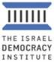

**July 2023**

**A majority of Israelis think that Israel is currently in a state of emergency** *This view is highly prevalent among opposition voters and those who oppose the government’s policies, and less so among those who support the government*

The July 2023 edition of the Israeli Voice Index, a monthly survey conducted by Israel Democracy Institute's Viterbi Family Center for Public Opinion and Policy Research, finds that 58% of Israelis believe the country is in a “state of emergency,” with only one-third who believe the country is not. These views are split based on political ideology, with less than one-third of voters for coalition parties believing Israel is in a state of emergency.

On the question of IDF reservists failing to report for duty in protest of the judicial overhaul, only a small minority of Israelis believe they should be dismissed from their reserve service—these results stand across the left (9%), center (13%) and right (33%).

As in previous months, just over one-third of Israelis are optimistic regarding both the future of democratic rule in Israel and the future of Israel's security, with the latter seeing a slightly larger, gradual decline than the former compared to previous months.

**Main Findings:**

**The Reasonableness Law**

Regarding the 'reasonableness amendment’ to the Basic Law on Judiciary, which passed limiting the Supreme Court's use of the reasonableness doctrine as a check on the executive branch of government, a majority of Israelis (54%) think the law is bad for democracy, while 35% believe the law is good for democracy. A deeper analysis of the results shows that a large majority of those who voted for a coalition party think the Reasonableness Law is beneficial, while only a negligible minority of opposition voters agree. A majority of voters on both sides of the political spectrum, however, believe a compromise would have been desirable. There are also sharp divides across different population groups, with only 12% of Arab Israelis saying the law is good for democracy, compared to 84% of ultra-Orthodox Israelis.

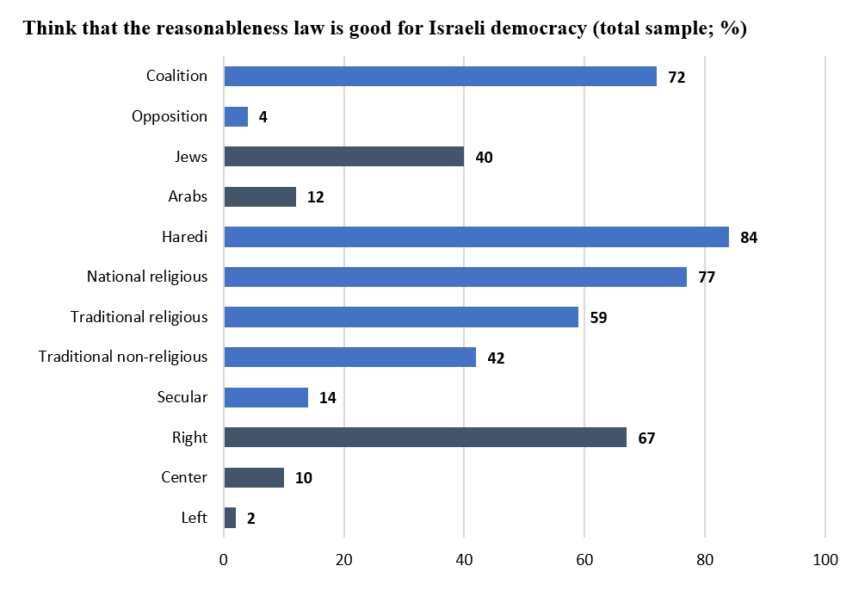

**Police and the Protest Movement**

Police have experienced a great deal of scrutiny since the start of the protests against the judicial overhaul. This month, we returned to a question we last asked in March 2023 about the functioning of the police at the protests. The share of those who think that the functioning of the police has not been good has grown significantly over the last four months—in March, 10% of those on the left gave the police a poor or very poor grade in their functioning at protests. Today, that number has risen to 62%. Among those on the right of the political spectrum, the share of those who gave the police a poor grade in March was 37.5%, and today that number is 33%**.**

**Future of the Government's Judicial Overhaul Legislative Program**

When asked what the government will do next regarding the judicial overhaul, the most common response by about one-third of those surveyed is that the government will continue with this legislative initiative as soon as the next Knesset session begins. A similar share (31.5%) think the government will continue at a slower pace, and 13% believe it will freeze the legislation for a limited period. Only 4% think the government will shelve the legislation.

**Future of the Protest Movement**

A majority of Israelis (56%) think the protest movement will grow stronger, while only 28% predict it will weaken. A further breakdown of the results reveals that a large majority of those on the left (87%) believe the protests will grow stronger, as does 65.5% of the center, while this view is held by a minority (albeit a large minority) of those on the right (45%).

**Future of the Economy**

Against the backdrop of warnings issued by major credit rating agencies, about half of the respondents believe their own financial situation will be harmed due to the negative impact of the reforms on the economy. Views about the potential economic consequences of the judicial overhaul are closely linked to political orientation.

**Prof. Tamar Hermann, Director of the Viterbi Family Center for Public Opinion and Policy Research said:** "Although many of our findings show continued, even deepened, polarization between voters for Israel's opposition and coalition parties, we also see some significant exceptions. For example, a majority on both sides of the political spectrum would have preferred to find a compromise prior to the passage of the most extreme form of the law eliminating the reasonableness standard, as well as a relatively moderate attitude (including on the right) regarding volunteer reservists who are not showing up for duty."

*The July 2023 Israeli Voice Index was prepared by the Viterbi Family Center for Public Opinion and Policy Research at the Israel Democracy Institute. The survey was conducted via the internet and by telephone (to include groups that are under-represented on the internet) between July 30 and August 1, 2023, with 615 men and women interviewed in Hebrew and 150 in Arabic, constituting a nationally representative sample of the adult population in Israel aged 18 and over. The maximum sampling error was ±3.55% at a confidence level of 95%. Field work was carried out by the Dialogue Research and Polling Institute. The full data file can be found at: https://dataisrael.idi.org.il.*