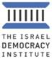

**August 2023 Israel Voice Index**

**Israelis are deeply divided on the upcoming Supreme Court hearings**

*In the August 2023 edition of the* [*Israeli Voice Index*](https://en.idi.org.il/articles/50752)*, a monthly survey conducted by Israel Democracy Institute's Viterbi Family Center for Public Opinion and Policy Research, we polled Israelis on the upcoming Supreme Court cases and found sharp divisions across partisan lines.*

A Supreme Court hearing is scheduled for September 12, 2023 to hear the petitions to strike down the Basic Law amendment limiting the use of the [reasonableness doctrine](https://en.idi.org.il/articles/50753)—that is, to overturn the first law passed in the coalition's controversial judicial reforms. We found that 41.5% of coalition voters and 6% of opposition voters said that the Court lacks the authority to perform judicial review over Basic Laws passed by Knesset (i.e., laws of quasi-constitutional status, as is the law in question). An additional 20% of coalition voters and 11% of opposition voters believe the Court should not intervene on the Reasonableness Law because it does not harm the democratic character of the state. All told, 34% of Israelis think the petitions to strike down the law should be accepted, 37% think it should be rejected, and 29% do not know.

Despite divisions on the Court hearings, an overwhelming majority of Israelis are in favor of a compromise over the judicial reforms, with 73% of Israelis agreeing that, in order to bridge divisions between the political camps, discussions should be held over legislative proposals and attempts made to reach compromises. These results are consistent with those of our surveys conducted in recent months.

**Main Findings:**

**Most Israelis think it is important to sign an agreement with Saudi Arabia—but the conditions matter**

According to recent media reports, the United States is holding negotiations with Saudi Arabia on regional strategic planning, including an extensive agreement with Israel. When asked how important such an agreement would be to sign, 57% of Israelis said it is fairly or very important, including 60% of Jewish Israelis and only 39% of Arab Israelis. However, when asked about the apparent demands of Saudi Arabia to develop a civilian nuclear program as part of such a deal, 57% of the sample also said that Israel should not sign on to such an agreement.

**A majority of Israelis think it is not legitimate to avoid the draft**

Recent media reports have covered various initiatives by prospective conscripts for military service and their parents, calling on their peers to try to avoid the mandatory draft (not to be confused with the refusal to perform voluntary reserve duty)—whether as part of the opposition to the government’s judicial reform program, or in the context of the possible passing of the new Military Service Law, which would provide a sweeping exemption from service for ultra-Orthodox (Haredi) yeshiva students. A majority of Israelis think it is illegitimate to avoid the draft in both situations, though a higher rate (40%) think it *is* legitimate to avoid the draft if legislation passes exempting Haredi Yeshiva students.

**Is it legitimate for young people to pursue courses of action to avoid being drafted into mandatory service in the IDF, in each of the following situations: as part of their opposition to the judicial reforms being advanced by the government; if legislation is passed to exempt Haredim studying in yeshiva from military service? (Jewish sample; %)**

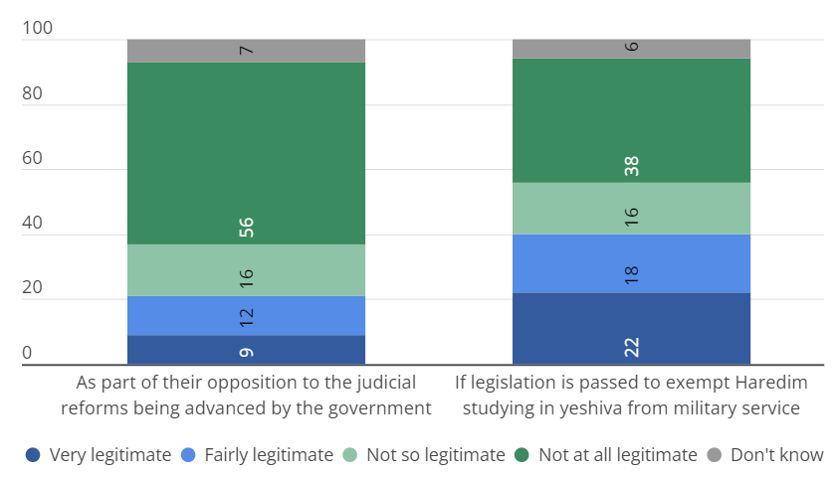

**The current government gets low grades on internal security, amidst a poor national mood**

61% of Israelis think that internal security (crime and internal terrorism) is worse compared to the period prior to the formation of the current government, while only 12.9% think the situation is better. Just over one-third of Israelis are optimistic about the future of Israel's national security and Israel's democratic rule—in both cases, Jewish Israelis are more optimistic than Arab Israelis, and rates of optimism increase with level of religiosity.

**A small majority of Jewish Israelis are against gender-separated bathing hours at public parks**

With tensions high surrounding gender separation in public places, we asked whether the public supports having separate bathing hours for men and women at natural springs administered by the Israel Nature and Parks Authority. A small majority of Jewish Israelis (54%) are against such proposals, though as expected, there are major gaps between different religious groups. 93% of ultra-Orthodox Israelis (Haredim) are in support of separate bathing hours, compared to 15% of secular Israelis.

[Click here to read the full study.](https://en.idi.org.il/articles/50752)

*The August 2023 Israeli Voice Index was prepared by the Viterbi Family Center for Public Opinion and Policy Research at the Israel Democracy Institute. The survey was conducted via the internet and by telephone (to include groups that are under-represented on the internet) between August 28 and August 30, 2023, with 621 men and women interviewed in Hebrew and 150 in Arabic, constituting a nationally representative sample of the adult population in Israel aged 18 and over. The maximum sampling error was ±3.55% at a confidence level of 95%. Field work was carried out by the Dialogue Research and Polling Institute. The full data file can be found at:* [*https://dataisrael.idi.org.il*](https://dataisrael.idi.org.il)*.*