Press Release
October Israel Voice Index & War in Gaza Survey
Israelis Overwhelmingly Trust the IDF Top Commanders Over the Prime Minister on the War, Even on the Right
The October 2023 edition of the Israeli Voice Index, a monthly survey conducted by the Israel Democracy Institute's Viterbi Family Center for Public Opinion and Policy Research, was conducted between October 24–26, 2023, using a nationally representative sample of 602 Jewish Israelis and 151 Arab Israelis. It finds a significant majority of Jewish Israelis trust the heads of the IDF over Prime Minister Benjamin Netanyahu to direct the war in Gaza and the northern front with Hezbollah.
On the Left, 80% trust the IDF commanders more and 4% trust the Prime Minister more, and in the Center, 74% trust the IDF commanders more. IDF commanders are also trusted the most on the right (41%) and, notably, only 10% said they trust the Prime Minister more. Compared to other political blocs, the right-wing bloc also has the highest share saying they do not trust either of them.
Even so, if elections were held in the foreseeable future, a majority of Israelis (55%) said that they would vote for a party in the same bloc that they voted for in last November’s election (40% said they would vote for the same party and 15% said they would vote for another party). Bloc loyalty is higher among opposition party voters (74%) than among coalition party voters (54%). 27% of Israelis said they have not yet decided for whom they will vote.
Additional Findings:
Israelis divided on the question of a hostage-prisoner exchange
On the question of whether it would be right or wrong to release large numbers of Palestinian prisoners held in Israel in return for the release of the Israeli hostages held by Hamas, a majority of Arab respondents (60.5%) are in favor of a deal of this nature, while Jewish respondents are divided with 45% who oppose it, and 40% who support it.
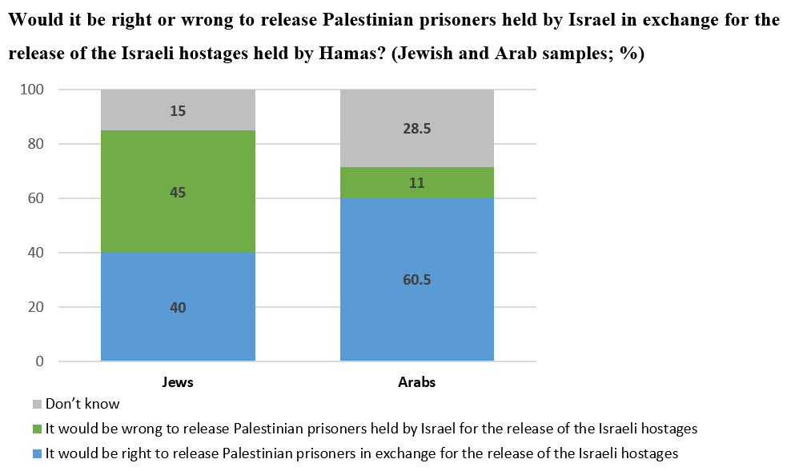
Israelis divided on whether the ultra-Orthodox should be drafted into the IDF
In light of a sizable number of young Haredim (ultra-Orthodox Israelis) having requested to enlist in the IDF since October 7, we sought out public opinion on drafting of Haredim. There is a large divide on this question between the Haredi and non-Haredi segments of the Jewish population. Three-quarters of Haredim believe that all Haredi youth should be exempted from military service in order to engage in Torah study. A majority of national religious Israels (56%), on the other hand, think that most Haredim should be drafted, with a small group exempt for Torah study. The most common response among traditional Jewish Israelis—including 34% of traditional-religious and 48% of traditional non-religious—was that Haredi youth should be drafted just like their non-Haredi peers, a view also held by two-thirds of secular Jews.
Most Israelis think the October 7 failures should be investigated after the war
When asked when it would be appropriate to examine who is responsible for the failures that led to the October 7 Hamas massacre, a large majority of Israelis (63%) think this should be postponed until after the war. While there is a majority across the board, large differences were found on this question in the Jewish sample, with only half of those on the Left in favor of postponing such an inquiry, compared with two-thirds in the Center and more than three-quarters on the Right.
More Jewish Israelis and fewer Arab Israelis think relations between the two groups are bad
We found a decline in the share of Jewish respondents who say that relations are bad (32%) compared to the previous measurement in February (45%). Among Arab respondents, meanwhile, the picture looks quite different: the share who characterize Jewish-Arab relations as good has fallen from 33% in February to 21% today.
Levels of optimism for the future of democratic rule and security continue to rise
In line with the findings of the War in Gaza surveys we have conducted since mid-October, this month’s survey also found an increase in the share of optimists regarding both the future of democratic rule in Israel and the future of Israel’s security. Optimism was higher among Jewish Israelis (43%) than among Arab Israelis (26%) regarding the future of democratic rule, and 46% versus 18%, respectively, regarding the future of Israel’s security.
Israelis think Hamas' decision to attack at this time was influenced by judicial reform divisions
A large majority of the public (70%) think that the disagreements between supporters and opponents of the government’s judicial reforms influenced Hamas’s decision to execute its attack plans at this time (Jews, 75%; Arabs, 46%).
The handling of the home front and evacuees
Only a minority of respondents—among both coalition and opposition voters—rate the functioning of government institutions regarding the evacuees and the home front (such as organizing the education system, providing alternative housing and equipment for evacuees, and managing Israel’s public relations efforts abroad) as good or excellent. Around half rate their functioning as satisfactory on the provision of essential services such as electricity, food, and water.
CLICK HERE TO READ THE FULL SURVEY
The October 2023 Israeli Voice Index was prepared by the Viterbi Family Center for Public Opinion and Policy Research at the Israel Democracy Institute. The survey was conducted via the internet and by telephone (to include groups that are under-represented on the internet) between October 24–26, 2023, with 602 men and women interviewed in Hebrew and 151 in Arabic, constituting a nationally representative sample of the adult population in Israel aged 18 and over. The maximum sampling error was ±3.55% at a confidence level of 95%. Field work was carried out by the Dialogue Research and Polling Institute. The full data file can be found at: https://dataisrael.idi.org.il.

