For Immediate Release
War in Gaza Survey
Flash Survey: Israelis support immediate negotiations to release the hostages while fighting continues
The Israel Democracy Institute's fourth War in Gaza Survey, conducted by our Viterbi Family Center for Public Opinion and Policy Research, finds that the highest share of Israelis think that Israel should negotiate for the release of the hostages immediately, but should not halt the fighting.
In fact, support for this option has risen by 10 percentage points since we first asked this question in October. We also found a small increase of around 3.5 percentage points, relative to the first two times we asked this question, in the minority view that negotiations should begin immediately even if this means halting the fighting. By contrast, there has been a fall of 9 percentage points in the share of respondents who think that negotiations with Hamas should only be held when the fighting is over.
The survey found that Israelis have given Prime Minister Netanyahu very low grades in his wartime performance, though his rating has improved slightly among coalition party voters (from 45% to 49%). It has remained unchanged and exceedingly low among opposition party voters (4%). IDF combat forces, on the other hand, got the highest grade among Jewish Israelis (93%).
Additional Findings:
Most Arab Israelis say they feel a part of the State of Israel and its problems
The survey finds a 20-year high of both Jewish (94%) and Arab (70%) Israelis who say they feel a part of the State of Israel and its problems. Notably, since this question was last asked in June 2023, the rate who feel part of Israel and its problems increased by 22% among Arab Israelis (from 48% to 70%) and 9% among Jewish Israelis (from 85% to 94%).
Even on the Right, most Israelis think the government's focus on the judicial reforms affected the timing of Hamas' attack; Israel's preparedness
61 percent of Israelis think the government's focus on the judicial reforms affected both the timing chosen by Hamas to carry out its attack and Israel's preparedness for such an attack. This majority holds across the full political spectrum: on the Left, 81% thought the focus impacted both Hamas' timing and Israel's preparedness, in the Center, 70% and 74% respectively, and on the Right, 55% and 53% respectively.
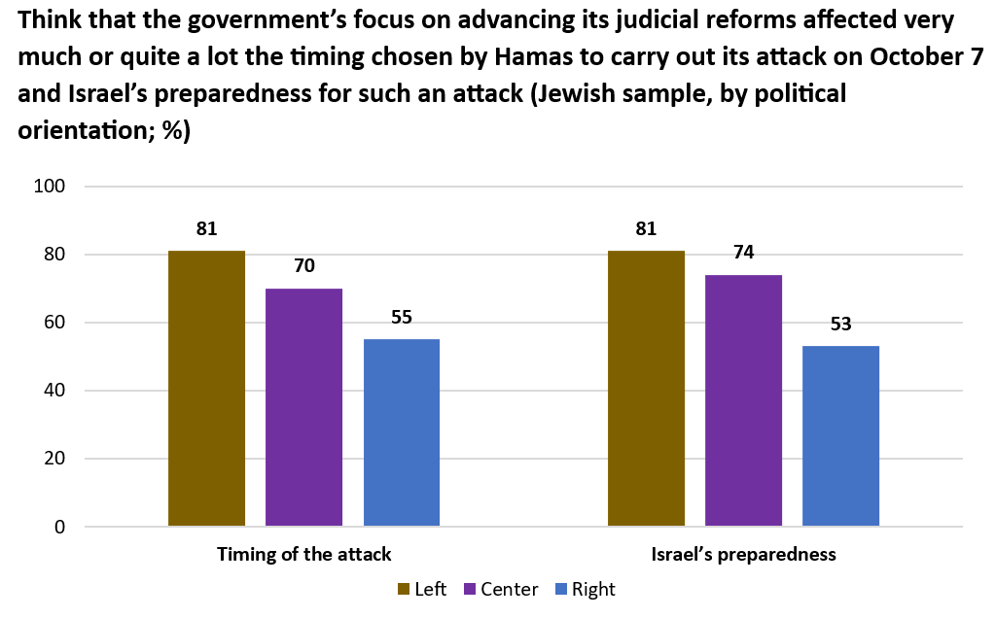

If given the option, Israelis would prefer to remain in Israel rather than live in a country abroad
We asked, “If you could receive American citizenship or citizenship of another Western country, would you prefer to move there to live or would you prefer to remain in Israel?” A majority of both Jewish (80.5%) and Arab (59%) Israelis prefer to stay in Israel, as does a large majority across all political orientations, including Left (66%), Center (80%) and Right (84%).
Both Jewish and Arab Israelis continue to assess high levels of resilience in society
In both the current survey and the survey conducted on October 18-19, the rating given by Jewish respondents to Israeli public resilience, in light of the challenges currently facing the country, was much higher than that awarded by Arab respondents, though on both occasions, the majority view in the Arab sample was that resilience is high.
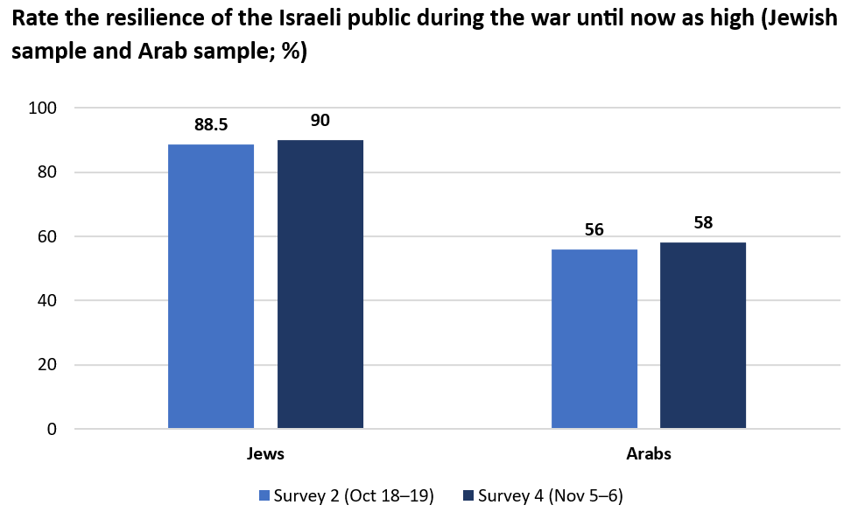
Jewish Israelis remain optimistic about the future; Arab Israelis' optimism reaches record-low.
In June this year, only one-half of Jewish respondents reported feeling optimistic about the future of the state, but this share has now grown to 72%. By contrast, we saw a small increase in optimism among Arab respondents immediately after the war began, but as the war has progressed, Arab optimism has gradually declined, to the point where only a quarter now say they are optimistic. This is the lowest share recorded since we began measuring optimism in 2009.
Israelis think ZAKA Search and Rescue should become a public service
We asked: “As a non-profit organization, a large part of the funding for ZAKA Search and Rescue comes from donations. Given the major national role played by the organization following the events of October 7, do you think that ZAKA should be adopted as a public service and thus be fully funded and managed by the state?” A very large majority (85%) of respondents are in favor of such a step, including 86% of Jewish Israelis and 76% of Arab Israelis.
Civil society gets high grades, particularly the new civic organizations
Immediately after the attack of October 7, civil society organizations rushed to plug the gaps left by the government and the state, by providing necessary equipment to soldiers, assisting evacuees, clearing away rubble and destruction, replacing missing manpower in agriculture, and more. These included both Israel’s established nonprofits and new civic organizations, or organizations that rapidly shifted the focus of their activities, such as Brothers in Arms. Public opinion is firmly tilted toward the new civic organizations, with 81% saying they are good or excellent, compared to 59% of established organizations.

The survey was conducted by the Viterbi Family Center for Public Opinion and Policy Research at the Israel Democracy Institute. Data collection was carried out between November 5–6, 2023, with 502 men and women interviewed via the internet and by telephone in Hebrew and 104 in Arabic. The maximum sampling error was ±4.04% at a confidence level of 95%. Field work was carried out by the Lazar Research Institute headed by Dr. Menachem Lazar.

