Press Release
Israeli Voice Index & 6th War in Gaza Survey
Israelis Sharply Divided on the Question of a Two-State Solution in Return for US Assistance
Among Jewish Israelis, 75% on the Left support making progress toward a two-state solution to the conflict in return for American assistance, compared to 45% in the Center and only 21% on the Right.
The November 2023 Israeli Voice Index, conducted by our Viterbi Family Center for Public Opinion and Policy Research, asked the following: President Biden has repeatedly stated that the large-scale assistance Israel is receiving from the United States is dependent on progress toward a fundamental solution of the Israeli-Palestinian conflict, on the basis of the two-states-for-two-peoples formula. In your opinion, after the war, should Israel agree or not agree to pursue this direction? About half of Jewish Israelis (52%) think Israel should not pursue a two-state solution, while most Arab Israelis (55%) believe it should.
This month’s Index also found that in the wake of the ceasefire ending, Jewish Israelis are united with 87% supporting the resumption of fighting against Hamas in Gaza in the same mode of operation as before. Only 20.5% of Arab Israelis expresses support for the fighting to resume.

Additional findings
Across the full political spectrum, a majority of Israelis supported the recent hostage-release deal
When asked whether Israel should have agreed to the deal for the release of hostages, including a temporary ceasefire, release of Israeli hostages, and the release of 3 times as many Palestinian prisoners, about two-thirds of Israelis said yes, compared with about a quarter who said no. A higher rate of Arab Israelis (72%) than Jewish Israelis (62%) supported the deal. The majority stands across the Left (84.5%) Center (64%) and Right (56%); across all Jewish religious groups except for National Religious/National Haredi (41%); and across voters of all political parties, except for the Religious Zionist Party (39%).
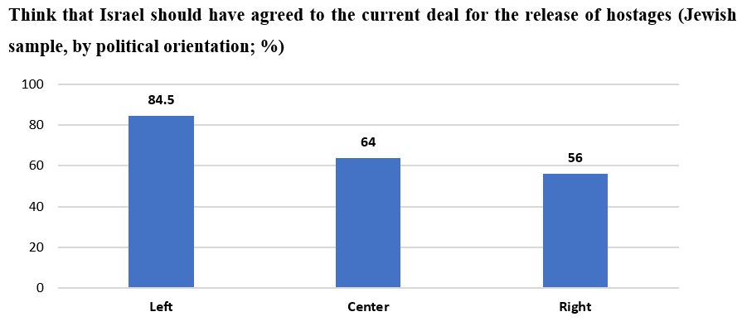
Overwhelming majority of Israelis supported the resumption of fighting in Gaza after temporary ceasefire
Among Jewish respondents, there is very strong support for resuming the fighting in Gaza as it was before the temporary ceasefire (87%), with a majority in favor across the political spectrum (Left, 74%; Center, 84%; Right, 93%). Among Arab Israelis, only 20.5% expressed support for fighting to resume as it was.
Rise in public optimism regarding the future of Israel's security and of democratic rule
For the second month in a row, we found an increase in the rate of Israelis optimistic about the future of Israel's security and the future of democratic regime (up to 46.5% and 46%, respectively). Rates of optimism are higher among Jewish Israelis than Arab Israelis for both the future of security (49.5% and 32% respectively) and for the future of democratic rule (49% and 32% respectively).
Fewer Jewish Israelis and more Arab Israelis are concerned about their physical and economic security
We looked at the rates of Israelis who said they were concerned for their physical and economic security in the survey taken October 18-19, compared to the present survey. Among Jews, the rate of concern for physical security is at 46% today, down from 63% in October, and concern for economic security is at 50.5% today, down from 57% in October. Among Arab Israelis, the rate of concern for physical security is at 73% today, up from 69% in October, and concern for economic security is at 82%, up from 69% in October.
Most Jewish Israelis think the country will be more united after the war
We asked: “Many people are talking about national unity at the moment. In your assessment, will the Israeli public be more united or more divided after the war than it was in the period beforehand?” The majority of Jews think (or perhaps hope?) that after the war, the Israeli public will be more united. Among Arabs, the most common response, though not a majority opinion, is that the Israeli public will actually be more divided than before. A particularly large share of respondents selected the “don’t know” response in both the Jewish sample and the Arab sample (22% and 25.5%, respectively).
Mass civil protests demanding accountability for October 7 expected after the war
A significant majority of both Jewish (73%) and Arab (64%) Israelis expect a large wave of protests after the war demanding that those responsible for the failures of October 7 are held to account. This majority stands across all political orientations, including 86% on the Left, 69% in the Center, and 74% on the Right.
Most Jewish Israelis support women serving in IDF combat roles
Against the backdrop of the many accounts of heroic wartime actions by female IDF combat soldiers, we asked Jewish respondents: “In your opinion, should the integration of women into combat roles in the IDF be expanded or reduced?” A majority think that integration of women in combat roles should either be expanded (51%) or maintained (24%), with only a minority saying it should be reduced (13%). The rate of support for expanded or maintained integration of women in combat roles is lower among more religious population groups.
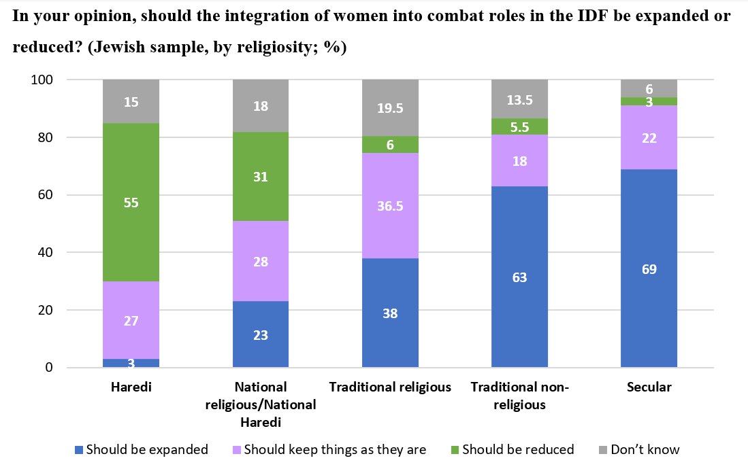

Changes in media consumption over the course of the war
The main news source for both Jewish and Arab Israelis was Israeli television channels and radio stations, both at the start of the war and today, though there has been a decline in the market share since October 7. In second place for Arab Israelis is television and radio news from Arab countries. News websites and the internet came in second place for Jewish Israelis, on the other hand. Among both Jewish an Arab Israelis, we have seen an increase in the numbers who use messaging apps such as WhatsApp or Telegram for their news, and interestingly, the prevalence of social media as the main source of news is lower among Jews than among Arabs, and it has even declined among Jews since the start of the war, while remaining stable in the Arab public.

The November 2023 Israeli Voice Index was prepared by the Viterbi Family Center for Public Opinion and Policy Research at the Israel Democracy Institute. The survey was conducted via the internet and by telephone (to include groups that are under-represented on the internet) between November 27–30, 2023, with 600 men and women interviewed in Hebrew and 151 in Arabic, constituting a nationally representative sample of the adult population in Israel aged 18 and over. The maximum sampling error was ±3.55% at a confidence level of 95%. Field work was carried out by the Dialogue Research and Polling Institute. The full data file can be found at: https://dataisrael.idi.org.il.

