Press Release
Israel Democracy Institute 7th War In Gaza Survey
Even on the Right, Israelis Want Elections Immediately After the War
Among Jewish Israelis, there is near-consensus on the Left (98.5%) in support of elections immediately after the war. This number stands at 85% in the Center and 51.5% on the Right.
The Israel Democracy Institute's War in Gaza survey, the seventh in a special series conducted by our Viterbi Family Center for Public Opinion and Policy Research, finds that over two-thirds of all Israelis (69%) believe elections should be held as soon as the war is over, including 66% of Jewish Israelis and 84% of Arab Israelis.
When asked how they plan to vote in the next election, among both Jewish and Arab Israelis, a majority say they will vote within the same political bloc, though many say they will change parties within said bloc, particularly on the Left. 28% of Israelis have not yet decided how they will vote.
Additional findings:
Most Israelis think IDF seeks to obey international law
An overwhelming majority of Jewish Israelis (91.5%) think the IDF is trying to obey international law and rules of war across all political orientations: on the Left, 88%; Center, 94%; and Right, 92%. By contrast, just under a quarter (24%) of Arab Israelis agree, with 66% saying the IDF is not trying to obey international law and rules of war, and 10% saying they don't know.
A majority of Israelis continue to believe the government does not have a plan for after the war
Two-thirds of Israelis currently think that the government does not have a clear plan of action for the day after the war, almost exactly the same proportion as we found in the survey conducted in the second half of November (November 19-20). The distribution of responses in both the Jewish and Arab samples is also the same as it was last time. When broken down by political orientation, we found 88% believe this on the Left, 84% on the Center, and 51% on the Right.
Most Jewish Israeli think international criticism of Israel is driven by antisemitism
Amid mass international protests and public criticism against Israel for its conduct in the war, 62% of Jewish Israelis think this is due to antisemitism and hatred of Israel, while only 7.5% think civilian casualties and destruction in Gaza is the reason. 22% say both are equal drivers. In contrast, only 10.5% of Arab Israelis attribute the criticism to antisemitism; 52% to civilian casualties and destruction in Gaza, and 11% to both equally.
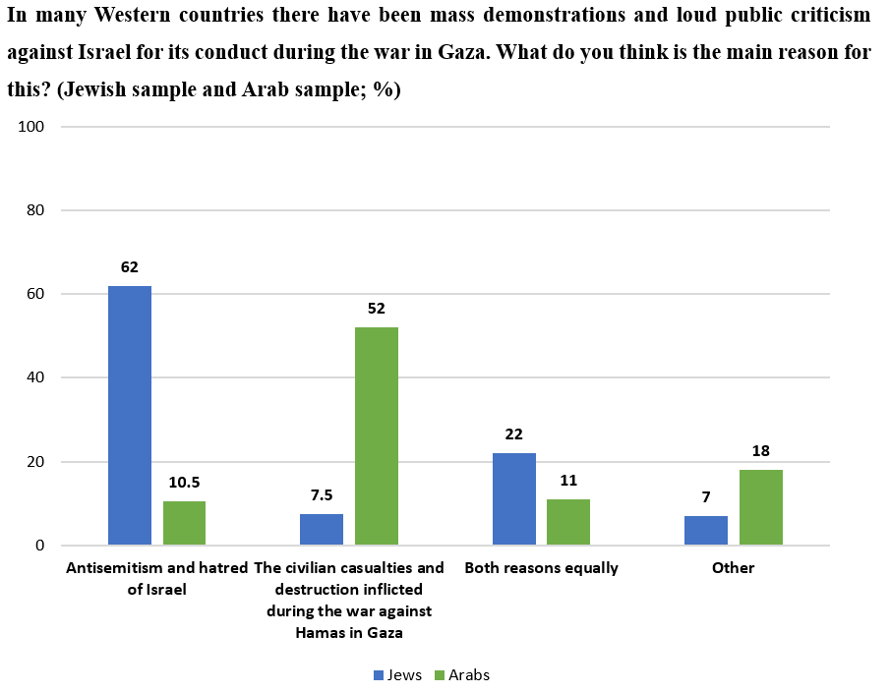
While the war goal of toppling Hamas is widely seen realistic, bringing all the hostages home is not
About two-thirds of Israelis think that the war goal of toppling Hamas is achievable. By contrast, just over a third (35.5%) think it will be possible to bring back all the hostages. Around a quarter believe that Israel will be able to achieve both these goals. Across the Left, Center and Right, a much larger share of respondents think that toppling Hamas is possible than think that Israel can achieve the return of all the hostages.
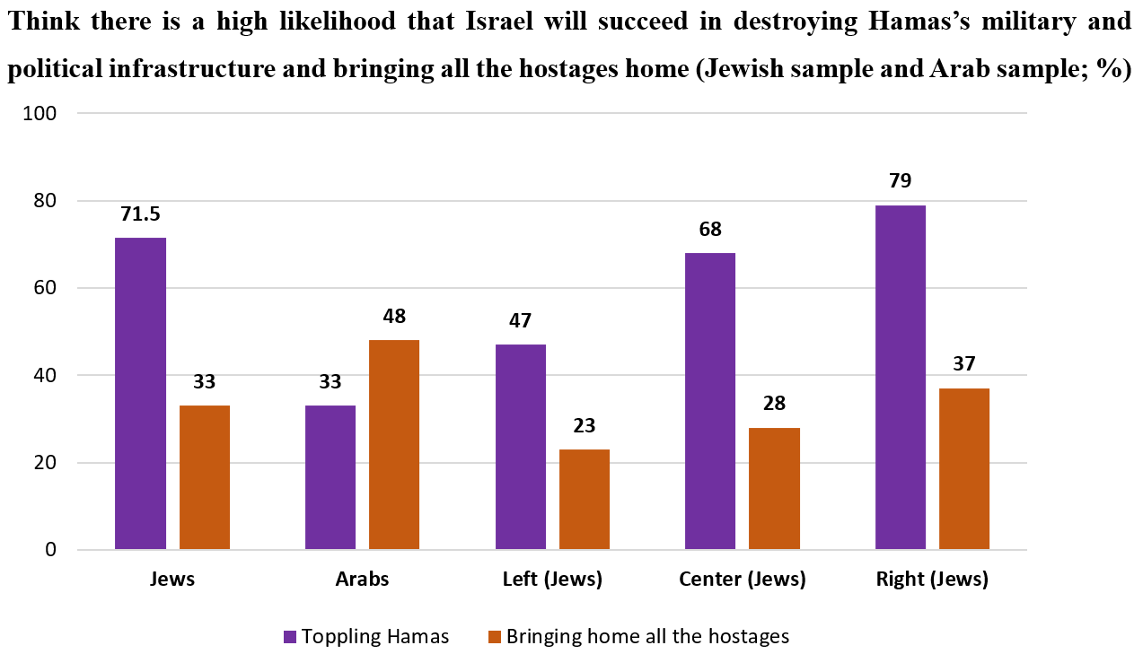

Israelis give low grades for Israel's PR efforts abroad regarding October 7 and the war
The overall assessment of Israel’s public relations efforts abroad regarding the events of October 7 and the subsequent war in Gaza is currently negative. In the Jewish sample, the most common view (though not the majority view) is that these efforts have been poor or very poor (49%), while in the Arab sample, this is the view of a small majority (53%).
Many Israelis are inclined to participate in protests after the war
Mass civil protests demanding accountability for the failures of October 7th have been predicted after the war. When asked whether they would personally participate, 44% of Jewish Israelis and 46% of Arab Israelis saying they would. This varies by political orientation. Not surprisingly, 85% on the Left and 60% in the Center say that they plan on joining protests after the war. On the Right, a minority—albeit a significant one considering the question (29%)—say they are planning to participate as well. We also found that the rates of planned participation decrease as level of religiosity increases.
Israelis are split on the question of whether their personal life has returned to normal
Some two and a half months into the war, 47% of Jewish Israelis reported that their lives have not returned to normal, compared with 51% who have resumed their previous routine. Among Arab Israelis 49% have not returned to normal while 40% have.
A majority of Israeli civilians report volunteering for the war
Three-quarters of Jewish Israelis and around 30% of Arab Israelis report participating in at least one volunteering activity since the beginning of the war, with higher rates of women volunteering than men. The most popular form of volunteering has been donations for soldiers and evacuees, followed by collecting, packing, or transporting equipment and food for soldiers, and in third place, the same activities for evacuees.
Consideration of the suffering of Palestinians
We asked whether the suffering of Palestinians should be taken into consideration in the war planning. Among Jewish Israelis, 40% say it should be taken into consideration to a fairly small extent and 41% to a very small extent. Among Arab Israelis, the trend is reversed, with 23% saying it should be taken into account to a fairly large extent and 60% to a very large extent. These trends are in line with results from the last time this question was asked in mid-October.
About one-third of Jewish Israelis say they feel closer to religion since the outbreak of the war
We asked our Jewish respondents: “Compared to the period before the outbreak of the war, do you now feel closer to or further from religion?” 34% said that they feel closer to religion now, 53% have experienced no change in this regard, and 10% say that they feel further away from religion than they did before the war.

This seventh flash survey was conducted by the Viterbi Family Center for Public Opinion and Policy Research at the Israel Democracy Institute. Data collection was carried out between December 11–13, 2023, with 503 men and women interviewed via the internet and by telephone in Hebrew and 101 in Arabic. The maximum sampling error was ±4.06% at a confidence level of 95%. Field work was carried out by the Lazar Research Institute headed by Dr. Menachem Lazar.

