Press Release
February 2024 Israeli Voice Index
War in Gaza Survey 12
Large Majority of Jewish Israelis want Changes to Haredi Conscription
70% of Jewish Israelis think exemptions given to the vast majority of ultra-Orthodox Israelis should be changed in light of the law set to increase burden on the already-serving public. Only 19% of ultra-Orthodox agree.
The Israel Democracy Institute’s February 2024 Israeli Voice Index—conducted by IDI’s Viterbi Family Center for Public Opinion and Policy Research—posed a question outlining the increased burden of IDF service to be placed on regular and reserve soldiers, and asked whether changes should be made to the exemptions currently granted to the vast majority of ultra-Orthodox (Haredi) Israelis. Among Jewish Israelis, 70% overall support changes. When broken down by religiosity, it is notable that only 19% of Haredi respondents supported making changes to the current arrangement. Among self-identified secular Jewish Israelis 86% support changes; traditional-non-religious: 77%; traditional religious: 52%; national religious: 65%. Among Arab Israelis, a sizable 43% of respondents said they did not know if changes should be made to the current arrangement.
The survey also asked about changes to the exemptions given for Arab Israeli military service, in which the Jewish public was divided—42% said exemptions given to Arab Israelis should be changed, versus 41% who said they should not. 53% of Arab Israelis said exemptions should not be changed, while 28% said they should.
Additional Findings:
Israelis support expanding military operations in Rafah
Against the backdrop of international pressure regarding military activity in Rafah, the survey asked whether Israel should refrain from expanding its military operations into Rafah so as “not to endanger relations with Egypt and the deal being brokered for the release of the hostages,” or if Israel should expand its military operations into Rafah “in order to pressure Hamas into agreeing to a hostage deal.” Around three-quarters of Jewish Israelis are in favor of expanding military operations into Rafah, while around two-thirds of Arab Israelis think that Israel should refrain from this course of action. Support for expanded operations likewise differs across the political Left (30%), Center (63%) and Right (88%).
Israelis divided on whether US commitment to Israel can be relied upon
In light of media reports about disagreements between the Israel and the US over continued the fighting in Gaza, the survey asked the extent which Israel can rely on continued massive American support for Israel. Public opinion is divided on this issue, with an inclination toward saying that Israel can still rely on the United States. Around 40% think that American support can be relied on fully or to a large extent, 34% that such support can be relied on to a moderate extent, and around 20% that such support cannot be relied on. Similar distributions of responses were found among both Jewish and Arab Israelis. When broken down by political orientation among Jews, the share of those who think that American support for Israel can be relied on is highest in the Center (47%), and lower on the Right (38.5%) and Left (29%).
Most Jewish Israelis: Benny Gantz should remain in Netanyahu's government
The survey asked: “In your opinion, should the National Unity party, led by Benny Gantz and Gadi Eisenkot, remain in the government headed by Netanyahu or leave it?” The majority of Jewish Israelis (62%) think that the party should remain in the government. Among those who say they would vote for Gantz’s National Unity party if elections were held today, three-quarters believe it should stay in the government. In fact, with the exception of Meretz, Labor, and Yesh Atid, the voters for all other Zionist parties think that the National Unity party should remain in the government. By contrast, the majority of voters for Arab parties think that it should leave.
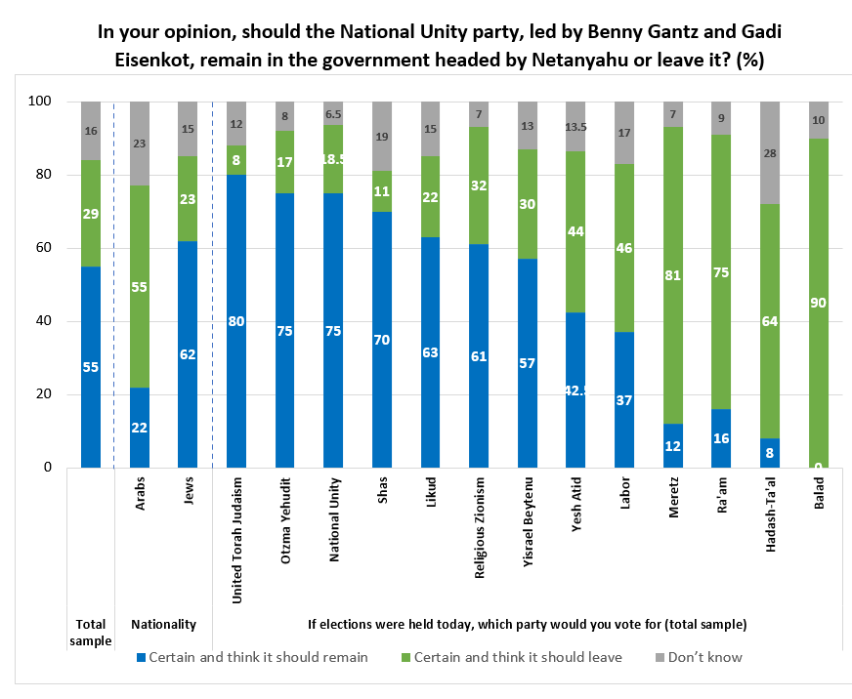

Israelis: restrictions to the Temple Mount during Ramadan will lead to violence
Against the backdrop of the security situation, the survey asked whether the restrictions the government has imposed on access of Arab citizens to the Temple Mount will increase, decrease, or not impact the likelihood of violence during Ramadan. Among Jewish Israelis, a plurality think these restrictions will increase the likelihood of violence (45%), an opinion also held by the majority of Arab Israelis (69%). Breaking down the Jewish sample by political orientation reveals that a large majority of those on the Left (67%) and in the Center (57%) think that the restrictions will make violence more likely, while just over a third of those on the Right agree (36%).
Plurality of Israelis think recovery from the war is likely
The largest share of Israelis (42%) think that there is a good or very good chance of recovery from the war, 30% rate the likelihood as so-so, and around one-quarter believe that the chances are not good. There is a large difference between Jewish (47%) and Arab (16%) Israelis on the likelihood of recovery, as well as across political orientations. 18% on the Left; 34% in the Center; and 59% on the Right think recovery from the war is likely.
Drop in share of Arab; Jewish Israelis who feel a sense of belonging to Israel
Unsurprisingly, at the beginning of the war we found a sizable rise in feelings of belonging to Israel and its problems, with a record-high reached of 70% among Arab Israelis. As shown in the graph below, this month’s survey clearly indicates that among both Jewish and Arab Israelis, these feelings have returned to pre-war levels, which may be explained as part of the process of returning to normal that we have identified in previous surveys.
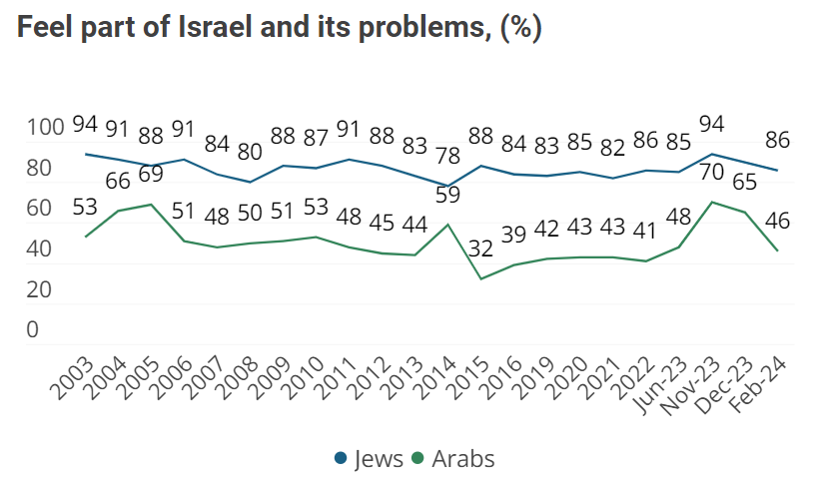
Very few Israelis think Israel has a positive standing in the international arena
Around half of the Israeli public think that Israel’s standing in the international arena is not good, while around a third think it is so-so, and only a minority that it is positive (21%). The share of Arab respondents who rate Israel’s international situation as negative (63%) is larger than the equivalent share of Jewish respondents (44%).

The February 2024 Israeli Voice Index was prepared by the Viterbi Family Center for Public Opinion and Policy Research at the Israel Democracy Institute. The survey was conducted via the internet and by telephone (to include groups that are under-represented on the internet) between February 28 and March 4, 2024, with 600 men and women interviewed in Hebrew and 150 in Arabic, constituting a nationally representative sample of the adult population in Israel aged 18 and over. The maximum sampling error was ±3.65% at a confidence level of 95%. Field work was carried out by the Dialogue Research and Polling Institute. The full data file can be found at: https://dataisrael.idi.org.il.

