Press Release
War in Gaza Survey 13
Majority of Israelis give low ratings to Prime Minister Netanyahu; high ratings to IDF Chief of Staff
Only 28% of Israelis give a positive performance rating to Prime Minister Netanyahu; 26% to Minister of National Security Ben Gvir; 18% to Minister of Finance Smotrich. IDF Chief of Staff Halevi earned high ratings at 48%; Defense Minister Galant at 40%.
The Israel Democracy Institute's War in Gaza survey, the thirteenth in a special series conducted by our Viterbi Family Center for Public Opinion and Policy Research, assessed the performance of various political and military leaders since October 7. Overall, IDF Chief of Staff Herzi Halevi topped the rankings of positive performance (48%), followed by Minister of Defense Yoav Gallant (40%) and Minister Benny Gantz (34%). Only 28% ranked Prime Minister Benjamin Netanyahu’s performance as positive (compared to 26.5% in November), while 57% of respondents ranked it as “poor” or “very poor.”
Across the political Left, Center and Right, Chief of General Staff Halevi tops the rankings, and Finance Minister Smotrich is in last place, while the positive performance ratings for each leader vary across political camps. The positive ratings for all the officials we asked about are higher on the Right than on the Left and in the Center, with the exception of Chief of General Staff Halevi and Minister Gantz, each of whom received a higher share of positive assessments from the Left and the Center than from the Right.
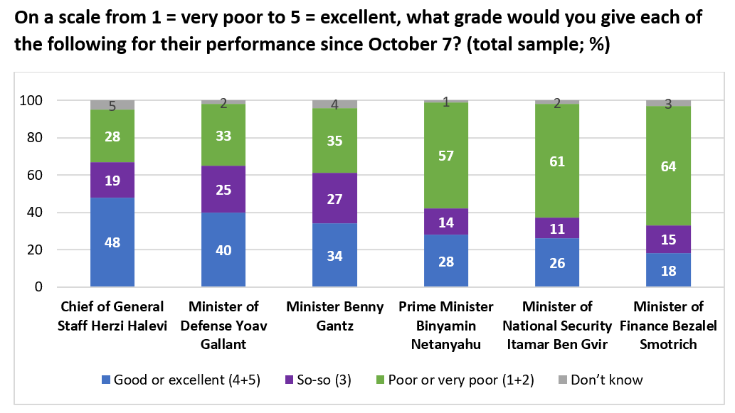
Additional Findings
Israelis remain divided on extent to which Israel should coordinate with the US
While the US and President Biden have stood beside Israel throughout the war, we know there are US demands that are not always acceptable to Israeli leadership—against this backdrop, we asked whether Israelis think Israel should act in coordination with the US or act only in accordance with the judgement of Israeli leadership. As in previous surveys, most Jewish Israelis think the judgement of Israeli leadership should take precedent, though there has been a slight increase among Jews who favor coordination with Americans, from 38% in January 2024 to 43% in the present survey. Arab Israelis consistently favor coordination with the US (63%), as do the Jewish political Left (82.5%) and Center (64.5%). The political Right (64%), on the other hand, favor the judgement of Israeli leadership.
Large majority of Israelis think an all-out-war with Hezbollah is likely to break out soon
More than two-thirds of Israelis think we are on the verge of an all-out-war with Hezbollah – 69% overall think this prospect is fairy or very likely; 71% among Jewish Israelis and 62% among Arab Israelis. This majority stands across the political Left (62%), Center (66%) and Right (74%).
Jewish Israelis think US construction of jetty in Gaza will weaken bargaining power with Hamas
We asked: “President Biden has announced that the United States intends to construct a port in Gaza to facilitate the supply of humanitarian aid. In your opinion, how will such a step affect Israel’s bargaining power vis-à-vis Hamas?" Among Jewish Israelis 60% think this would weaken Israel's negotiating position, compared to 23% who think it will strengthen it. Among Arab Israelis, 43% think such a step will strengthen Israel's bargaining position, compared to 39% who think it will weaken it.
Taking the suffering of Palestinians into account
When asked the extent to which Israel should take into consideration the suffering of the civilian population in Gaza in planning the next stages of the fighting, most Jewish Israelis (80%) think it should be taken into account to a fairly small extent or not at all. 72% of Arab Israelis, on the other hand, think it should be taken into account to a fairly large or very large extent.
Israelis agree with US intelligence reports on low faith in Netanyahu; mass protests
We asked: “A recently published report by US intelligence agencies states that (a) the Israeli public’s lack of faith in Netanyahu’s ability to govern has grown and intensified since the beginning of the war; and (b) large public protests can be expected, demanding Netanyahu’s resignation and new elections. To what extent do you agree with these assessments?” Overall, the largest share agrees with both assessments (42%). The second largest group is of those who do not agree with either assessment (28%). 16% agree with only the assessment about Netanyahu, and 8% agree with only the assessment about protests.
--
This thirteenth flash survey on the war in Gaza was conducted by the Viterbi Family Center for Public Opinion and Policy Research at the Israel Democracy Institute. Data collection was carried out between March 18–21, 2024, with 578 men and women interviewed via the internet and by telephone in Hebrew and 159 in Arabic. The maximum sampling error was ±3.68% at a confidence level of 95%. Field work was carried out by the Lazar Research Institute.

